Hi,

One ARMA III updated to reléase 1.68 and atarting the game with the following mods:

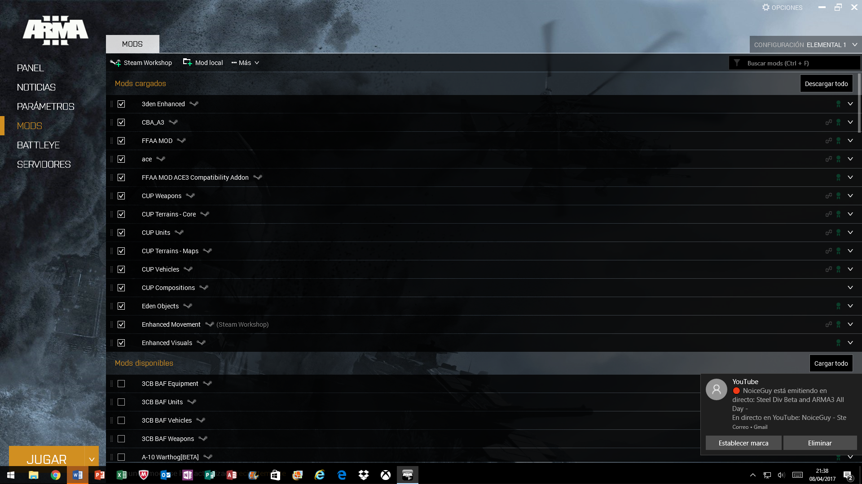

and once a territory is chosen, the following options are available when opening a soldier's menu:

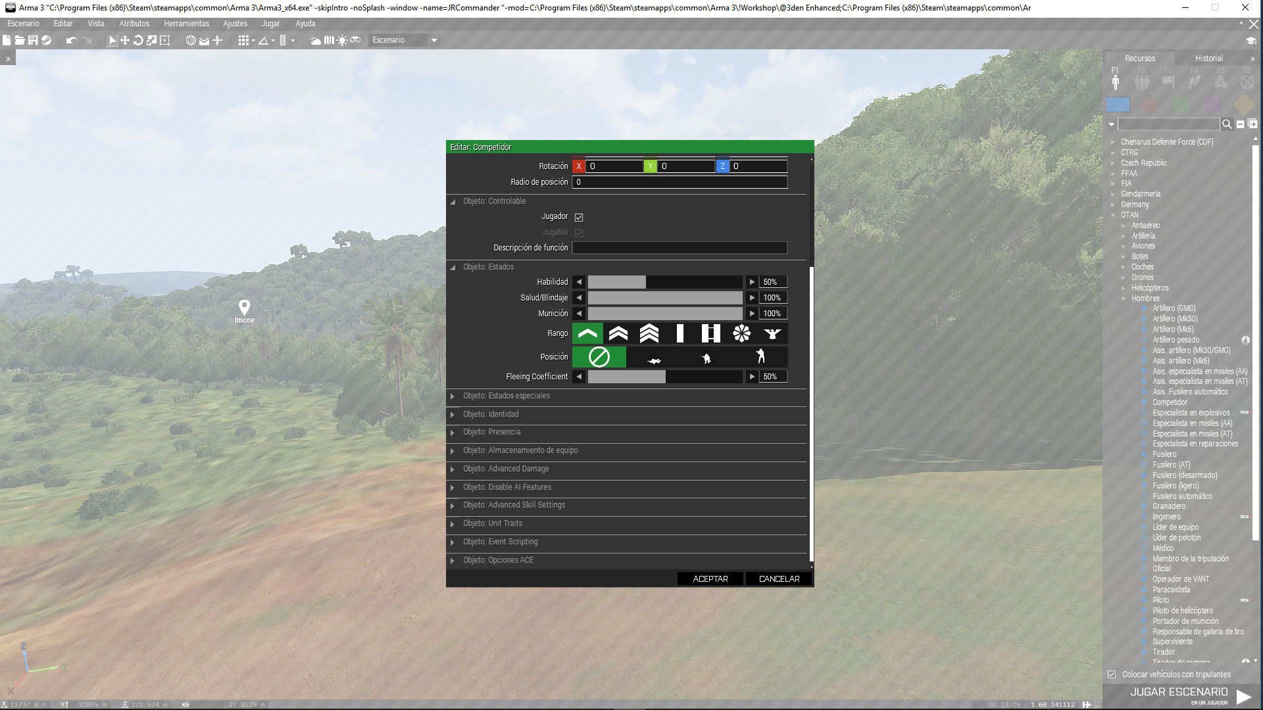

I have not available ("disappeared") the option I had before:

**AMBIENT ANIMATION**

With a lot of movement possibilities for the selected soldier.

These options are no longer available ¿???

Thanks in advance for your answer.