Setup Day Z Tool, Terrain Builder, and Bulldozer After 1.26 Sakhal Update

- Backup all old files:

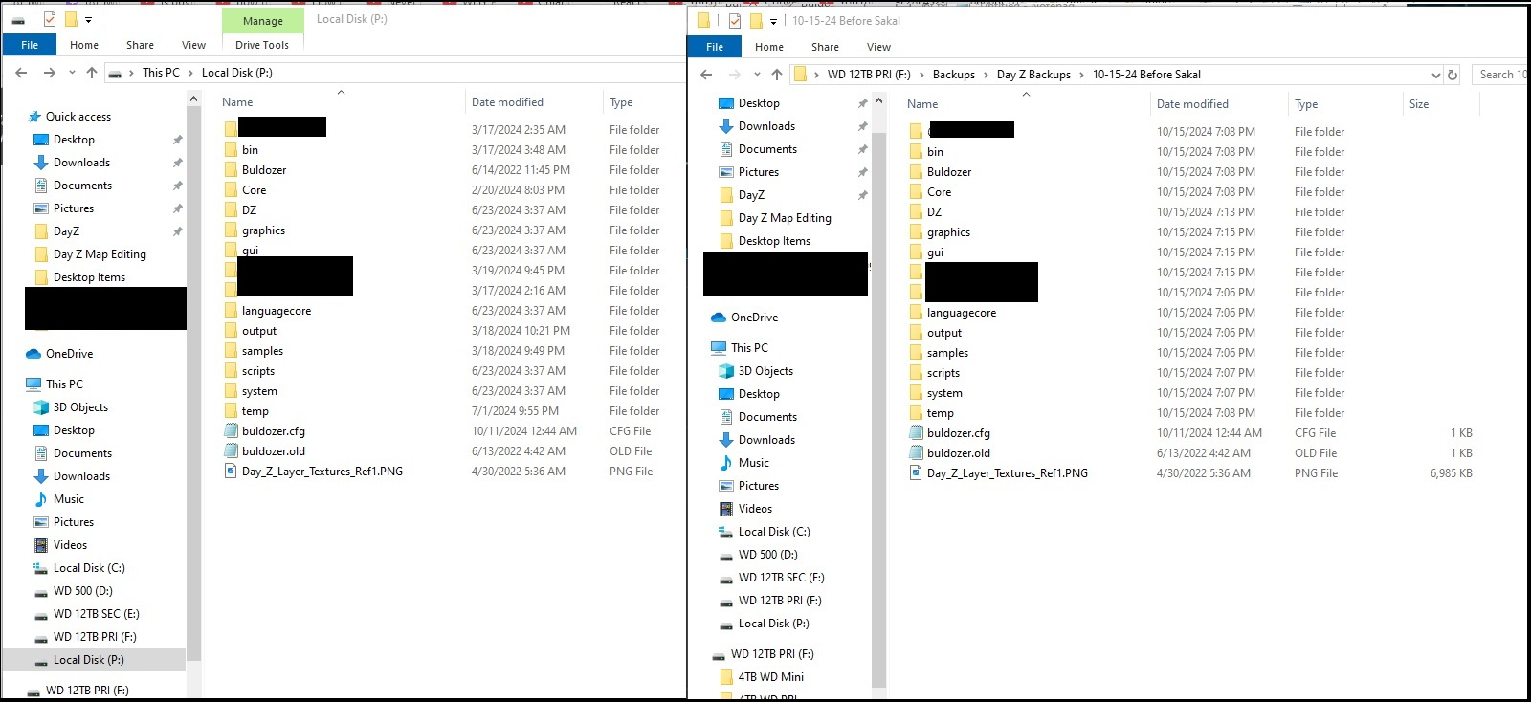
2. Download updated Day Z 1.26 and Day Z tools from Steam:

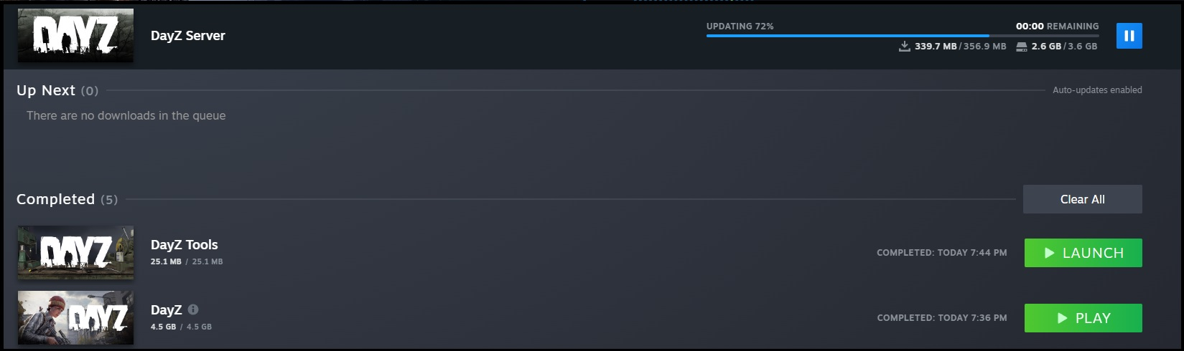

3. Verify game files in steam.
a. I also had to reboot the computer and launch Day Z and load into a map before I could get it to work properly.

4. Open Day Z Tools and mount the P:\ drive.

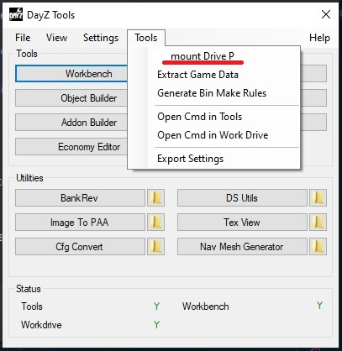
5. Next, extract game date by going to “Tools” then “Extract Game Data.” (This is assuming you already have the correct settings under “Day Z Tools” then “Settings” menu. If not, search YouTube on how to setup Day Z tools the first time. This extraction process will take awhile. Close the command prompt window when complete.
a. https://www.youtube.com/watch?v=OpdBIkhKZm4

6. Copy un-binarized roads to:
a. Unbinarised versions download: https://github.com/BohemiaInteractive/DayZ-Misc/tree/master/Road%20Parts/Chernarus (if you don't already have them downloaded) and replace all the files in P:\DZ\structures\roads\parts and P:\DZ\structures_bliss\roads\parts before Terrain Builder will work with roads properly.

(Note: When packing your map later on to test or for final output, you must first copy back the Binarized roads to those same folders before you pack the map or the roads won't work in game).

7. Open Terrain Builder:

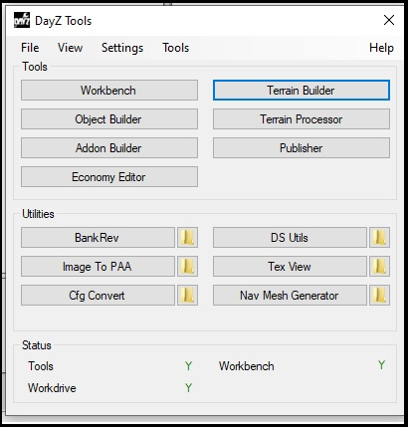
8. Open your existing project from the “File” menu then “Open Recent.”

9. You will seen an C++ error, hit ignore twice:

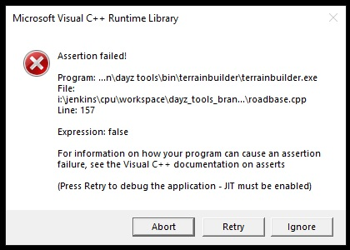
9. You will see a “Parce Layer cfg” error, press “Ok.”

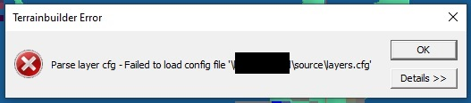
10. PANIC!
11. After your done panicking, you will see under “Library Manager” that the “Template Libraries” are missing all files.

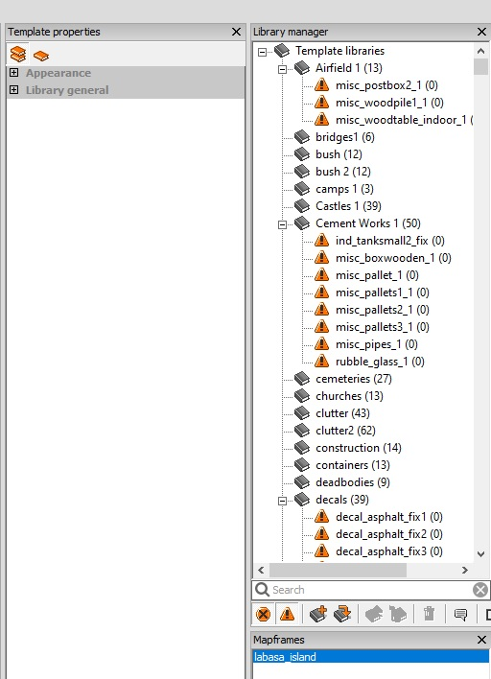

12. Right Click the “Template Libraries” and select the “Resolve Missing” option on the drop down menu.

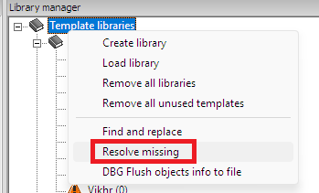

13. You will see a big red list of missing objects, hit the three dot […] menu next to “Search Directory.”

14. Navigate to P:\DZ folder and select that and press Ok/Open.

15. Check the box that says “Recursively” on the previous window.

16. Press the “Search Button.”

17. It will search for the missing files and re-link them to your Library.

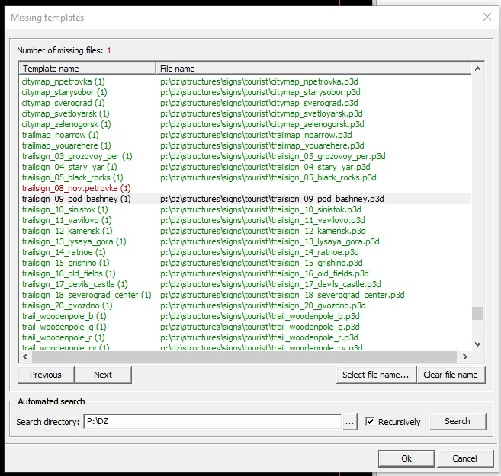
18. In my case it was still missing one file “trailsign_08_nov.petrovka” I think because of a naming error (the period).

19. Press “Ok” at the bottom.

20. The files should now be re-linked in your “Library Manager.”

21. With the update, Terrain Builder has had its settings to put to default. Navigate to the “Window” menu at the top and select the “Layers Manager” window. The Layers Manager will appear in the lower right which should contain your “Rasters, Objects, and Shapes.”

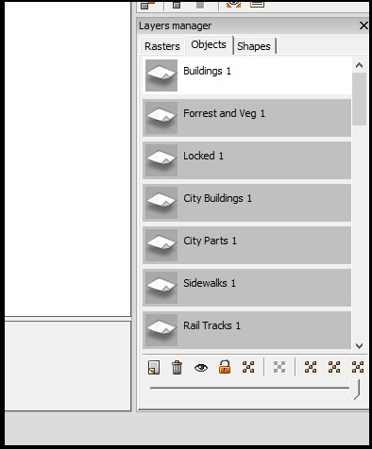
22. The Sat Map will not be visible by default, go to the “View” menu in the upper left and click on “View Satellite Image.”

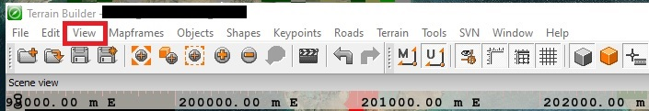

23. Ensure you have the correct Satellite Map visible in the “Layers Manager” window at the bottom right. Select the layer and press the “eye” icon at the bottom to ensure its visible.

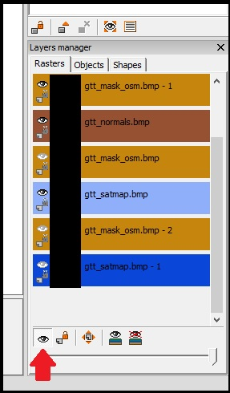

24. Next, navigate to “Tools” and the “Preferences” at the top. Update the “Data Directory” to P:\

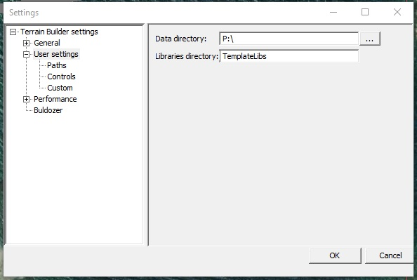
25. Click “Buldozer” on the left hand side and then update the “.exe file path” and the “Launch Parameters” so Buldozer will work.
a. .exe file path: C:\Program Files (x86)\Steam\steamapps\common\DayZ\DayZ_x64.exe
b. Launch Parameters: -buldozer -name=Buldozer -window -exThreads=0 -noLogs -noAsserts -cfg=buldozer.cfg

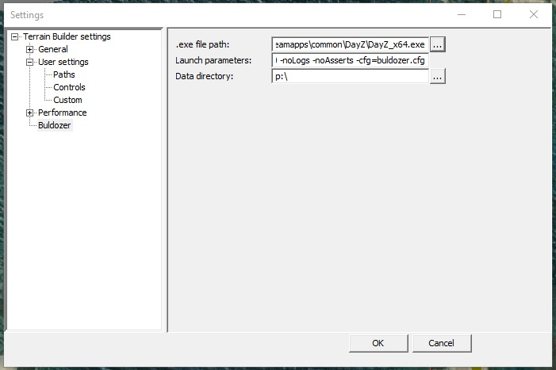

26. Press “Ok” at the bottom.

27. Save the Terrain Builder project, then close Terrain Builder and then relaunch it.

28. Test Buldozer to see if it works. It should launch. Ignore any errors you see.

29. If your road on your map looked like wire frames in straight line squares, setting the P:\ in preferences and restarting Terrain Builder should have fixed that as well. You should see roads in Buldozer.

30. If your mouse scroll wheel has been inverted after the update, you can change it back under the “Tools” menu, then select “Preferences” again and on the left click “controls. Check the box that says, “Revert Mouse Wheel” and click OK at the bottom. That should put the mouse wheel scroll back to normal.

